Jenkins Tutorials

Jobs

Job Name : SCM Job

1. Free style job will be used for SCM Job - git pull job

Plugin used - Git Plugin.

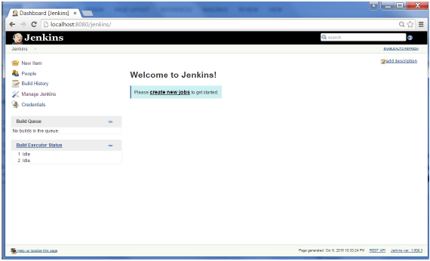

Manage plugin

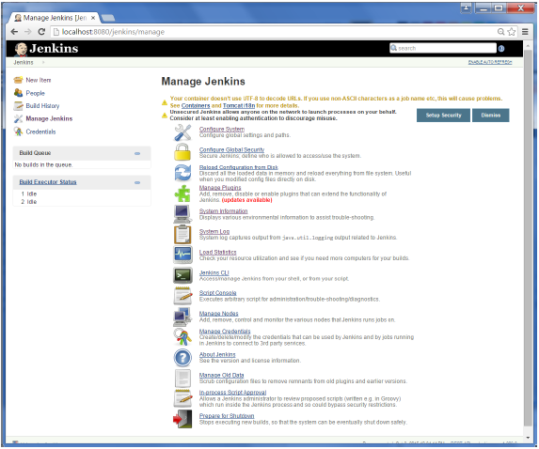

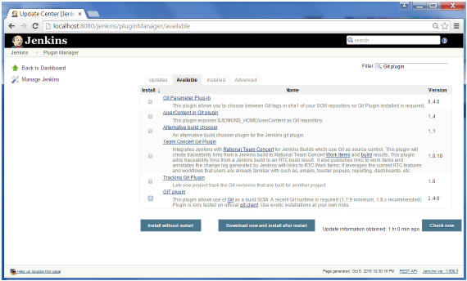

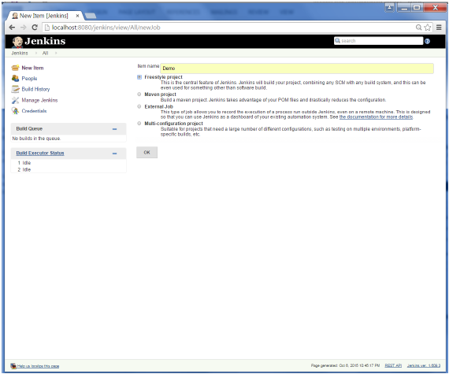

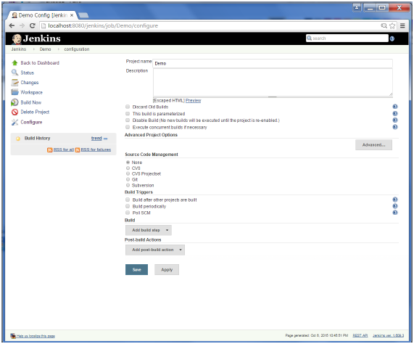

2. Maven Job - Maven Project Plugin

Create Maven Job. - Job Name : Build

3. Deployment Job

Create Deployment Job

Plugin - Deploy plugin (Deploy to Container plugin)

Name : Deploy

4. Workflow Job

Plugin : Workflow plugin

Name Workflow

5. Pipeline Job

Plugin : pipeline plugin

1. Using grovy inline grovvy script
2. Using Jenkins file

6. Create Dashboard

Plugin : Dashboard view

Name : JobView

7. Status Monitor Job

Plugin : Status Monitor

Name : JobStatus

Additional Plugin information -

<https://docs.google.com/document/d/1qse3nlcmeJU2bmclVeZmGgb64x8pcvTv2U8HiZJ8MUE/edit?usp=sharing>